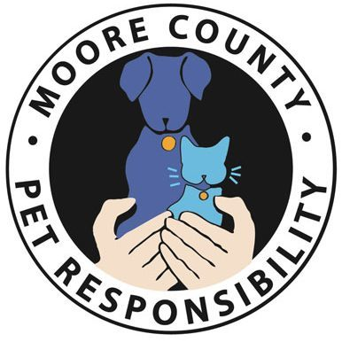
Pet Responsibility Committee - Home Learning Plan Lessons 1-6
Thank you for taking the time to learn about how to be a responsible pet owner, and how to be
an advocate for the pets around us!
- Lesson 1
  - Slides
  - Activities:
    - I CAN statement
    - Just Like ME game (for classroom session)
    - Discuss what responsible vs Irresponsible pet ownership looks like
    - Watch Best Friends video
    - Discuss pet overpopulation challenge in Moore County
      - 2019 Moore County >400 dogs and >650 cats euthanized
    - Tale of two pets (for classroom session)
    - Pet Responsibility Word List
      - Write out definitions of each word
    - Ticket out the door
      - Write out what it means to be a responsible pet owner
    - Crossword Puzzle
- Lesson 2
  - Slides
  - Activities:
    - Discuss the benefits of spay and neuter
    - Discuss spay and neuter, and how just one male and female cat\dog can generate over 20,000 offspring in only 4 years
      - Do you have anything in quantity? Pretzels, M&M’s, ??? Start with 2 of the item representing a mom and dad pet, they have 2 boy and 2 girl babies (so now you have 6 items) and show how fast this can multiply…especially with 3 litters possible per year.
    - Tale of two pets (for classroom session)
    - Discuss intake of animals into the Moore County Shelter in 2018, and how spay and neuter can have a huge positive impact on reducing these numbers
    - Review Animal Center/Spay Neuter Clinic/Emergency Trifold Brochure
    - Discuss what you can do if you find a lost pet. Emphasize that the child must go find an adult before interacting with a pet…lost or living in a home.
    - Speuter Story
      - Ask your student to write a short story about how they can help stop overpopulation. Can be a real experience, or they can make up a relevant story.
- Lesson 3
  - Slides
  - Activities:
    - How your student, and then your pets, can be healthy and safe? (exercise, good nutrition, car seat, handwashing, social distancing…walking dog on leash, collars, brushing pets to keep coat healthy, good pet food, fresh water, etc)
    - Discuss treatments for pets to help keep them healthy (flea, tick, heartworm, vaccines, etc).
    - Watch videos
      - Dog Listener
      - Dog Body Language
      - Dog Stars (bite prevention)
    - 3-2-1 Summarizer – write down how to keep pet safe, healthy, and how your student can be safe.
- Lesson 4
  - Slides
  - Activities
    - Safety for you and your pet
      - Can you complete the sentences?
      - What did you learn from this exercise?
    - Dollars and Sense
      - Review all of the things to consider before getting a pet
    - Two tales (for classroom sessions)
    - Things you’ll need for your new pet
      - Discuss how much they think these things on the list will cost for the first month the pet joins the family. Total the amount. Compare to the actual costs (in the slides) and discuss the differences between what the student thought and real costs
    - Pictures of families (including pets) over the years. Discuss the long-term commitment that is required by adopting a pet, and enjoy all the happy pictures.
    - Discuss how long pets live, and how that compare to human year life expectancy.
- Lesson 5
  - Slides
  - Activities
    - True False (for classroom session)
    - Watch Two Important Places video
    - Review Animal Center \ Clinic \ Emergency services info if haven’t yet.
    - Pet Profiles \ Tale of Two Pets (for classroom sessions)
    - Discuss how your student can be an advocate for pets.
    - Draw pictures that represent what you have learned in these sessions (aka what a responsible pet owner does, what spay and neuter means, etc. and give to teachers once class is back in session)
- Lesson 6
  - Slides
  - Activities
    - Speuter (for classroom session)
    - Guest Speaker
      - Watch TNR video
    - Two Happy Tales (for classroom session)
    - Art and Speuter Contest (for classroom session)
    - Read the puppy story and discuss what was irresponsible, and what is responsible.
    - Color a thank you to the different animal services in the area, to give to the teachers once class is back in session

